# Appendix : Wireframes of EasyConnect (List of Figures)

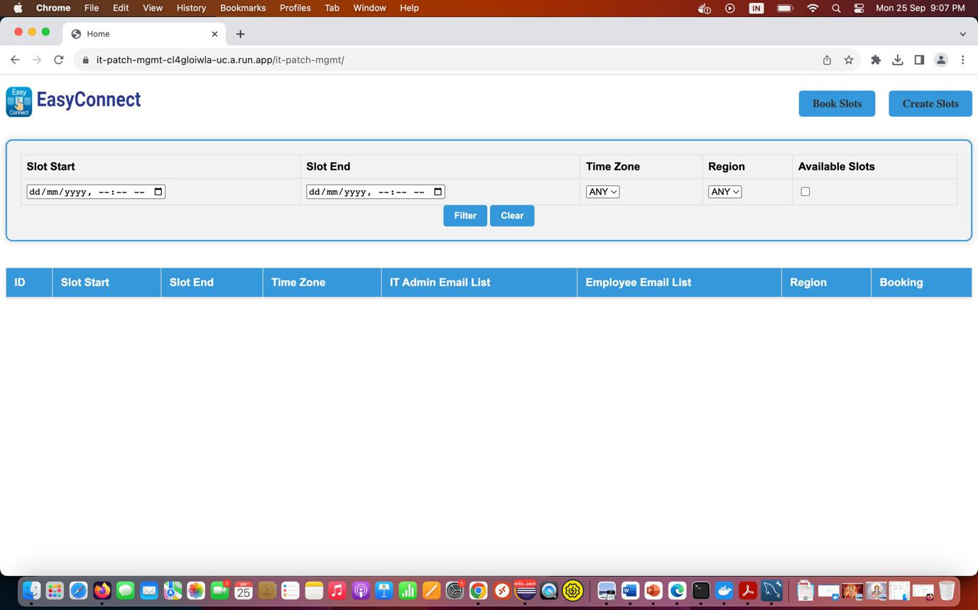

### Home Page1

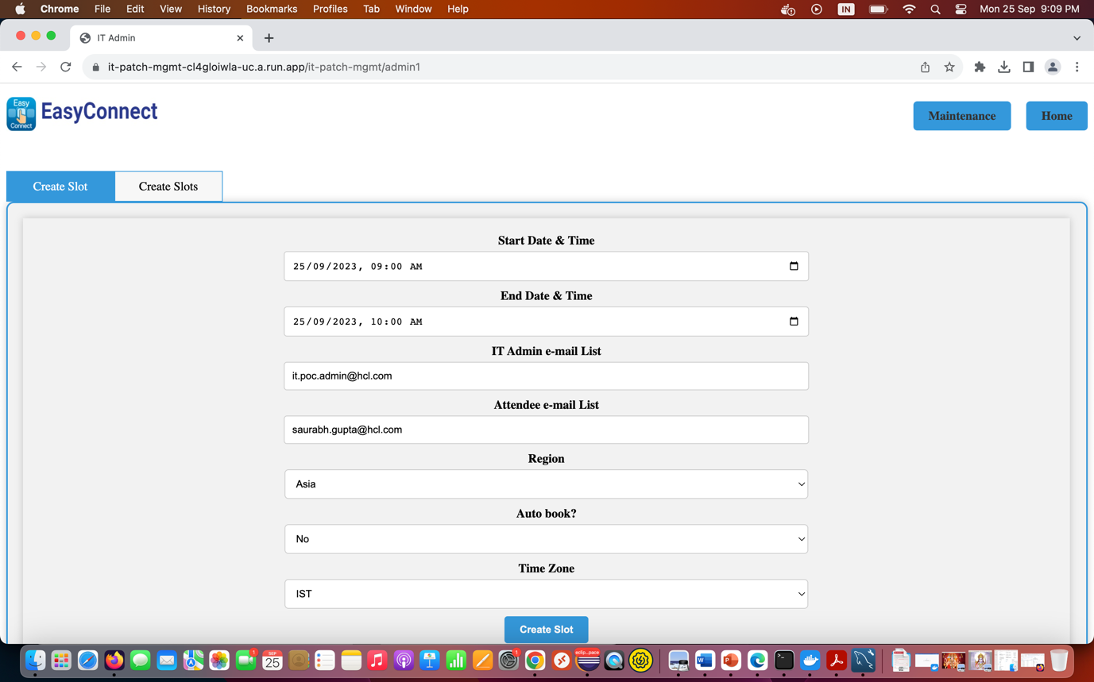

### Create Slot Option by Admin

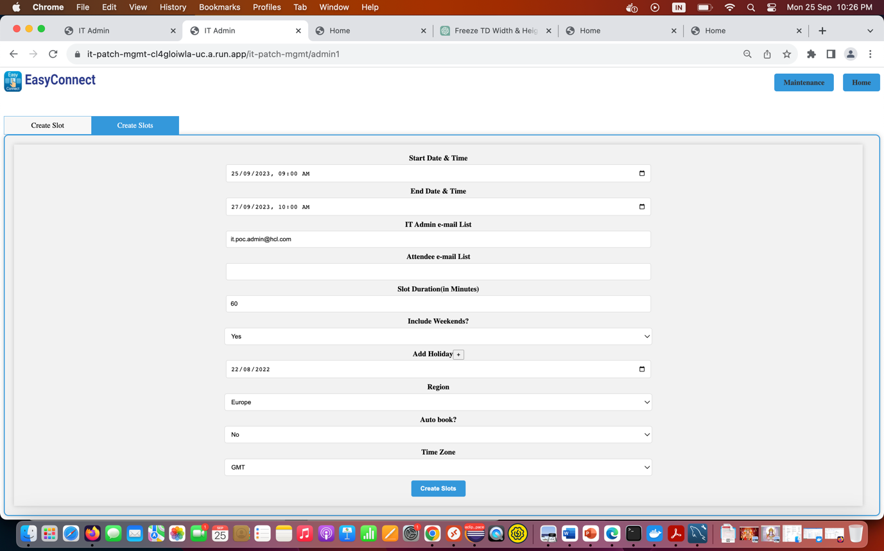

### Create Slots Option by Admin

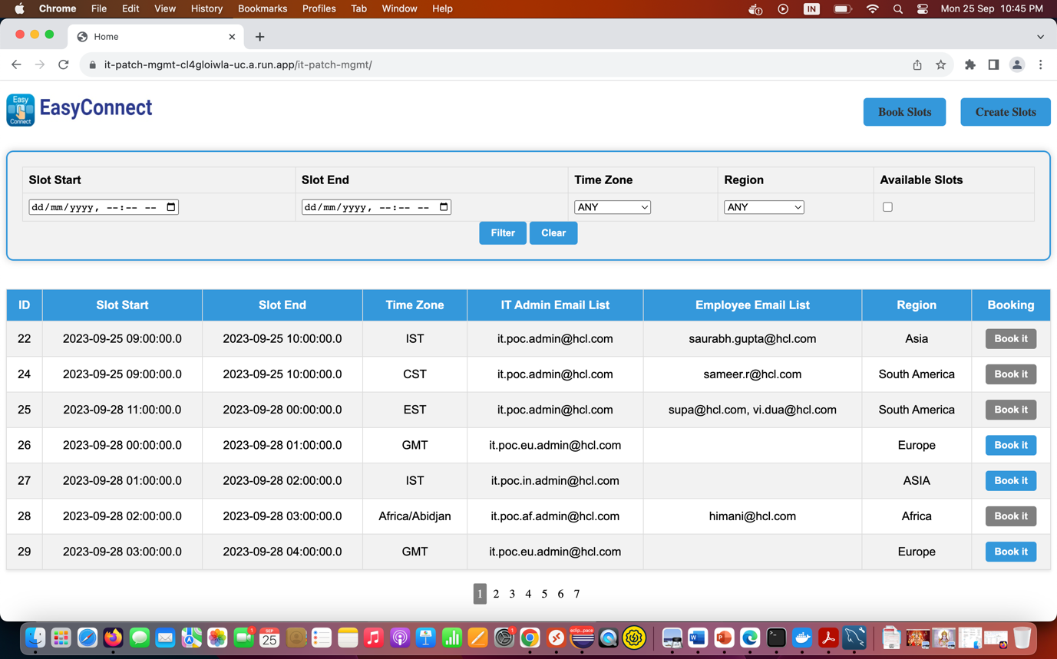

### Home Page2

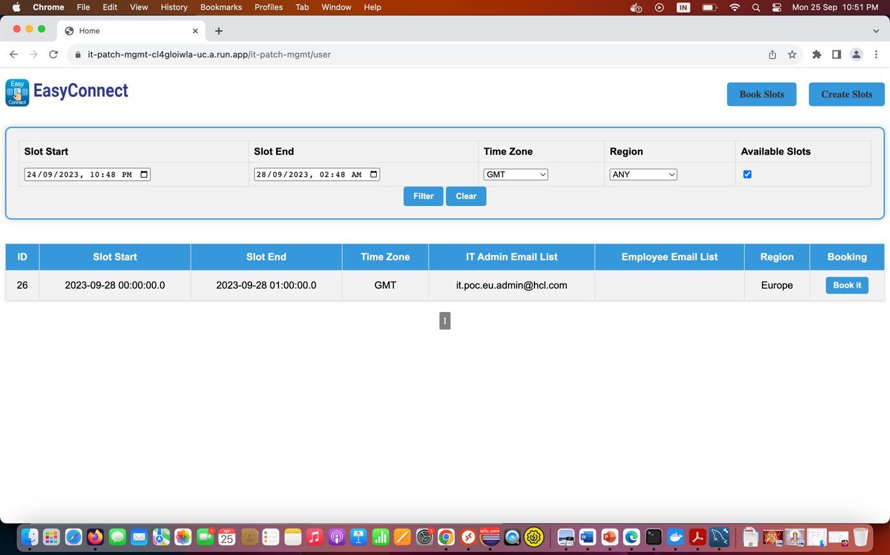

### Filter & Search Option

## 

## Dashboards

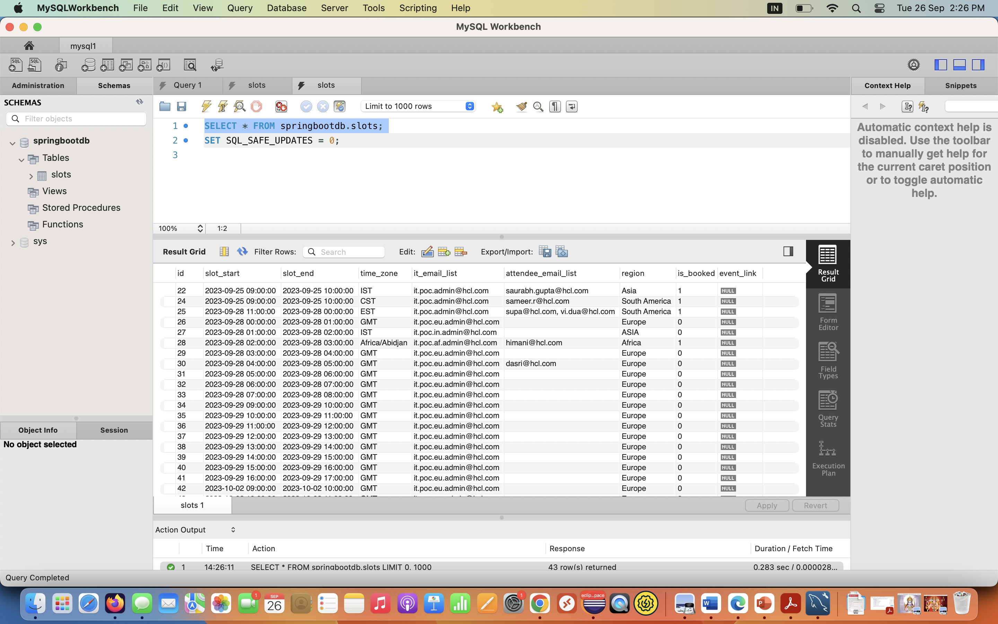

### MySQL Workbench connecting to Cloud DB instance

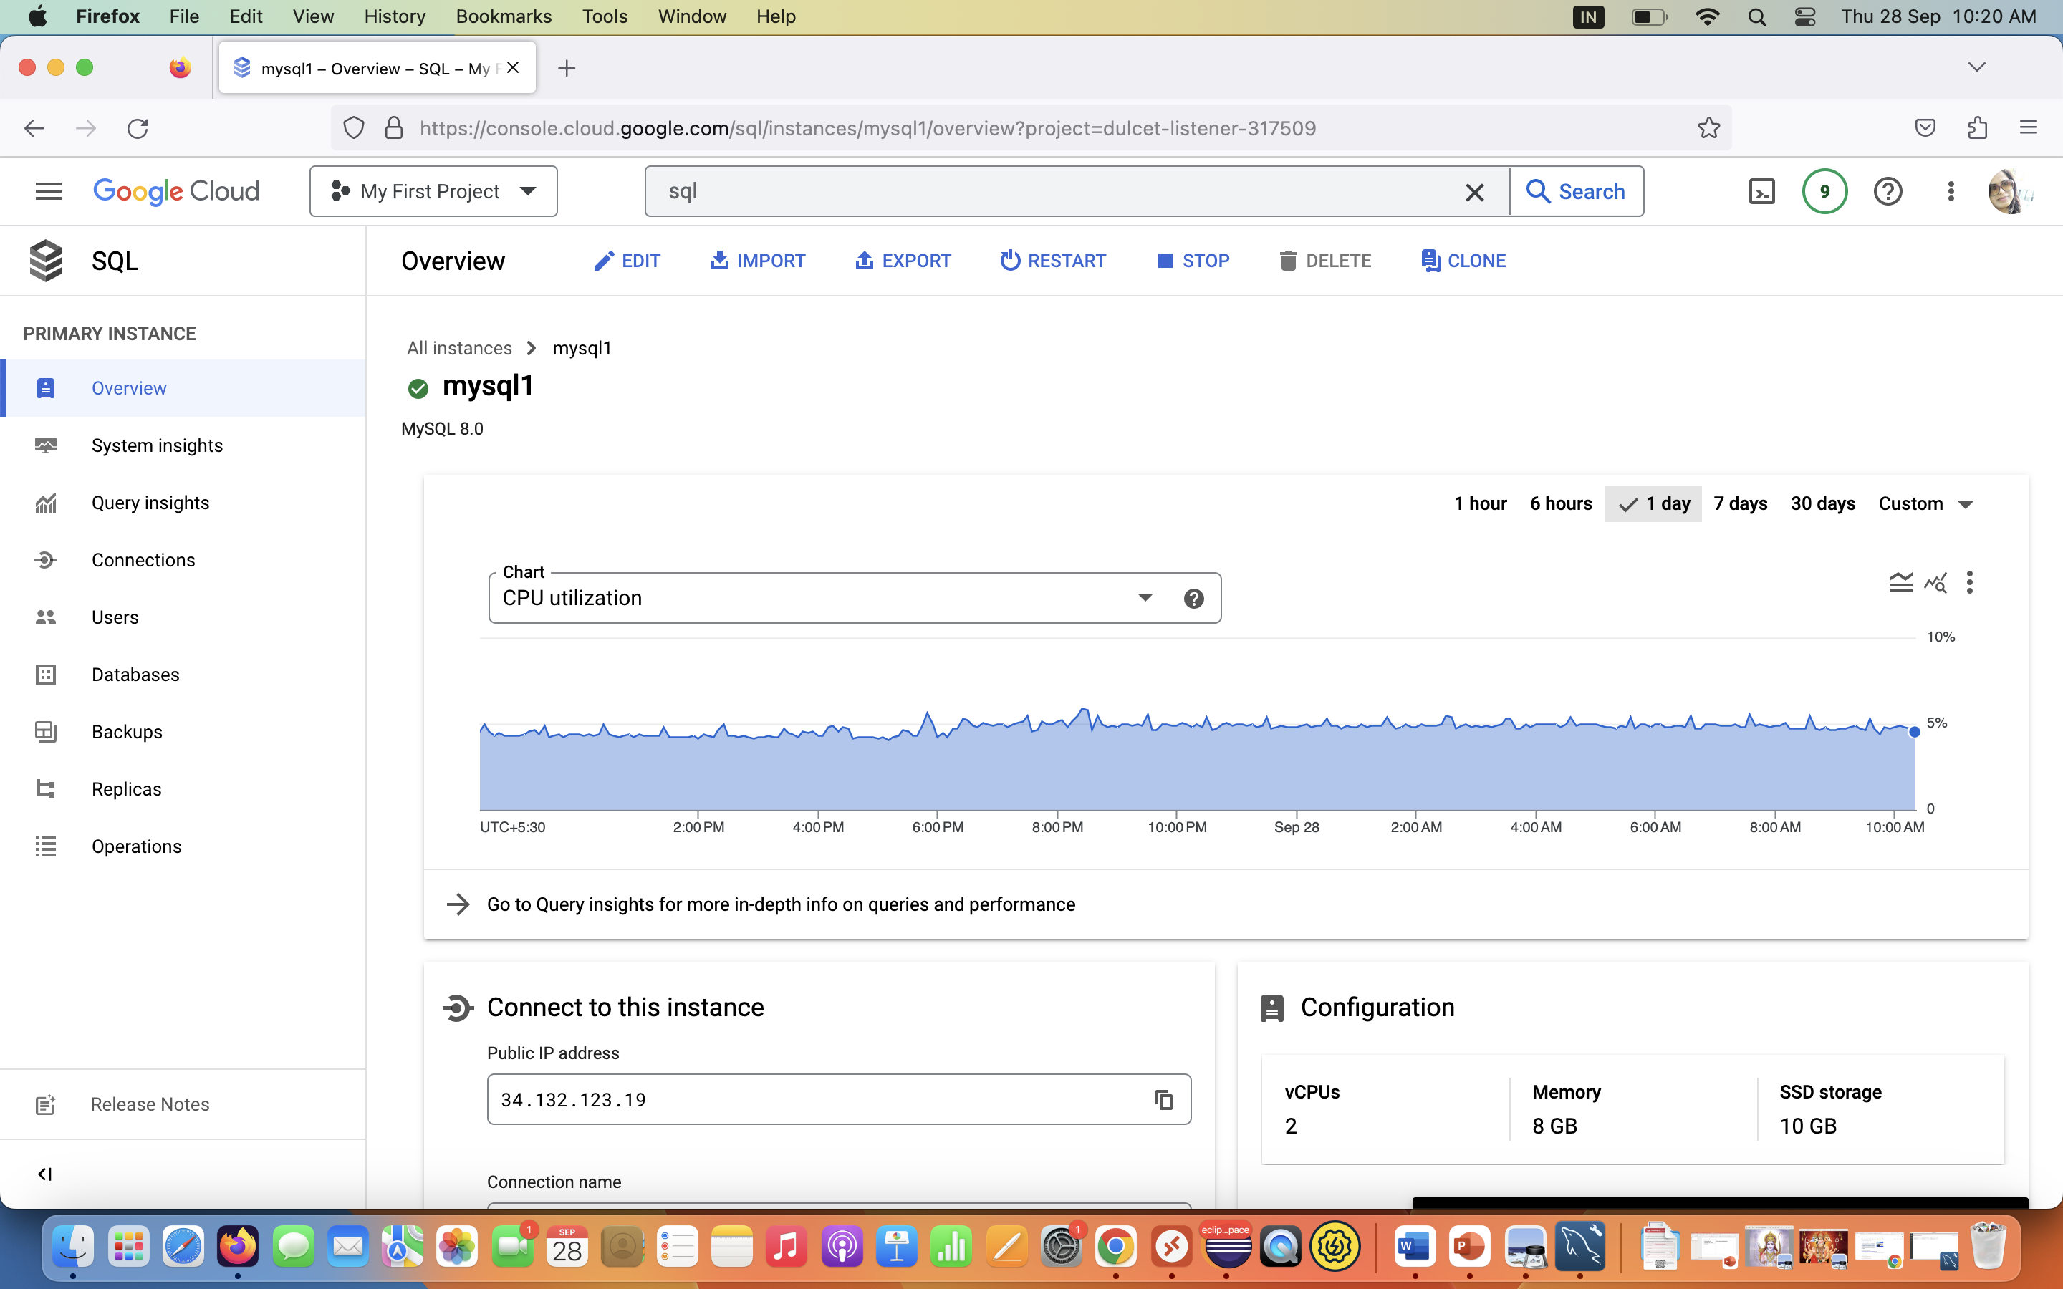

### MySQL Database instance and metrics

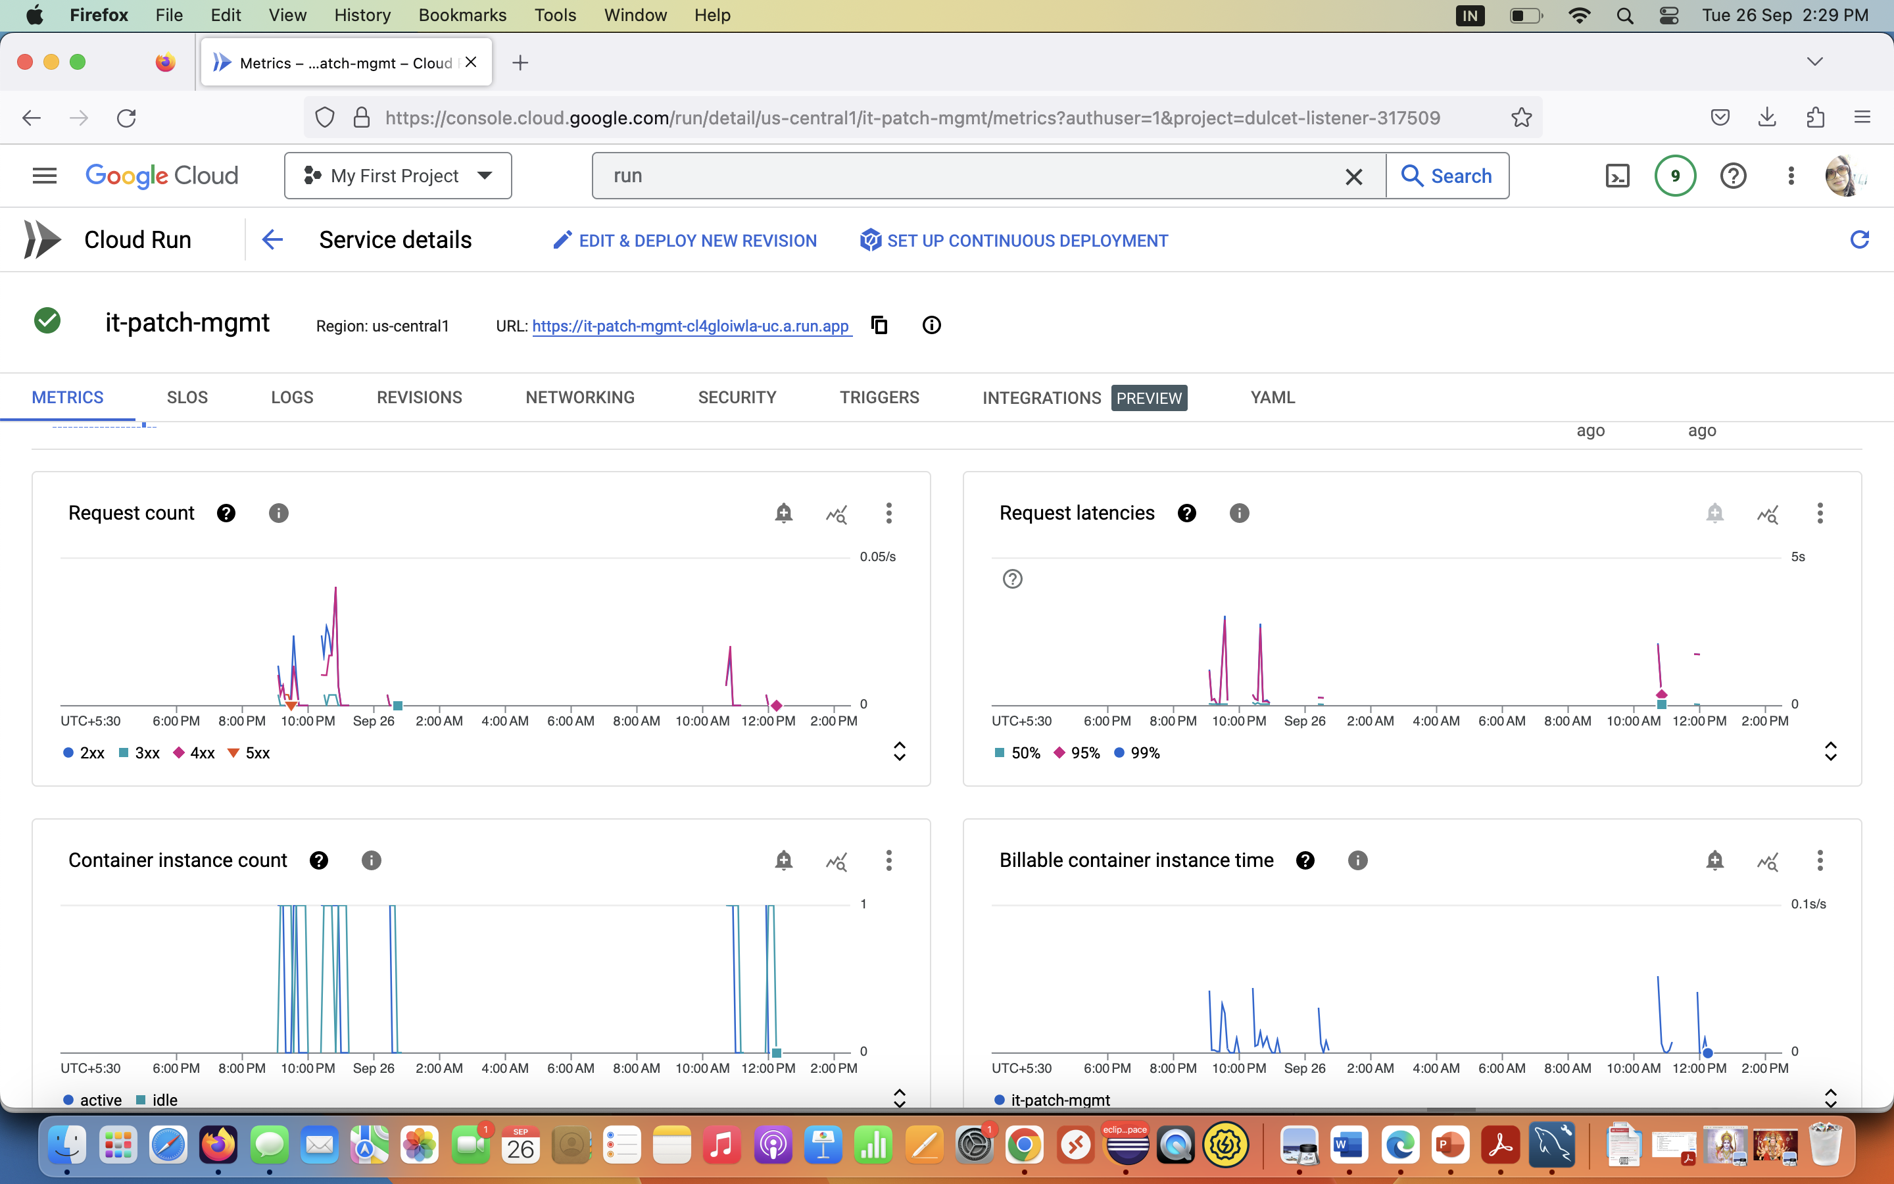

### Serverless Cloud RUN and key Metrics

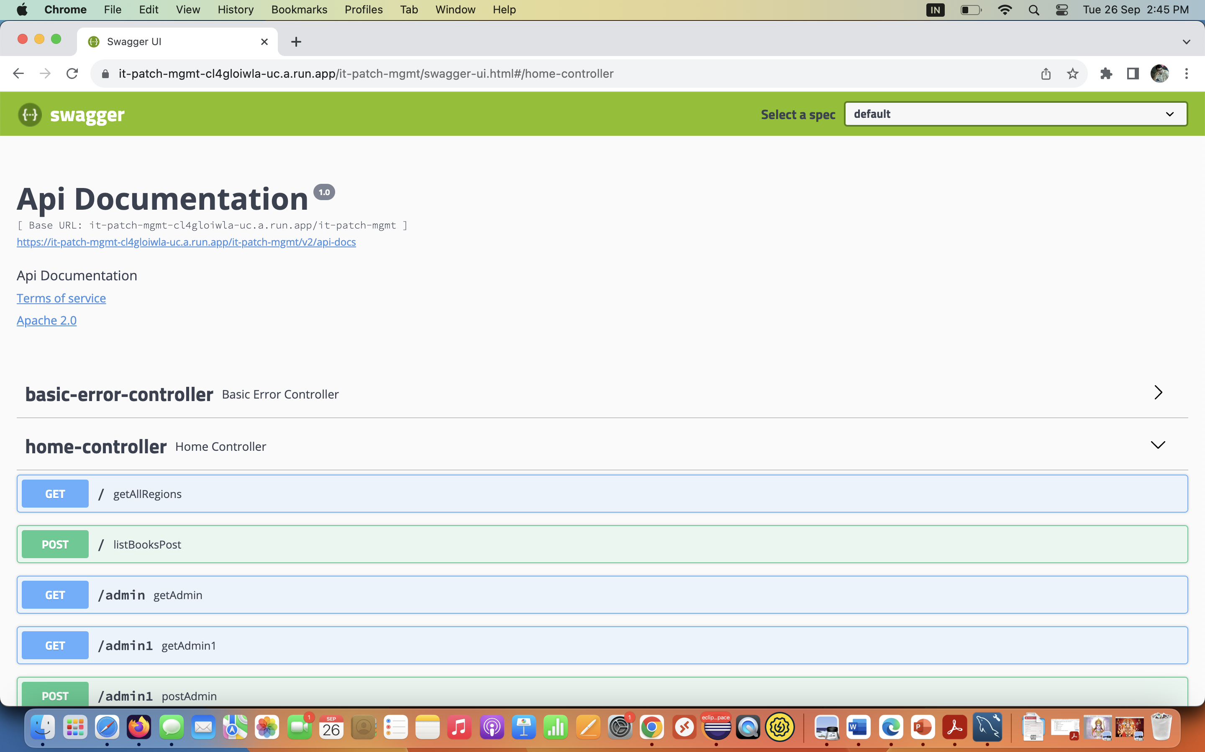

### Swagger (Open API) UI for testing APIs

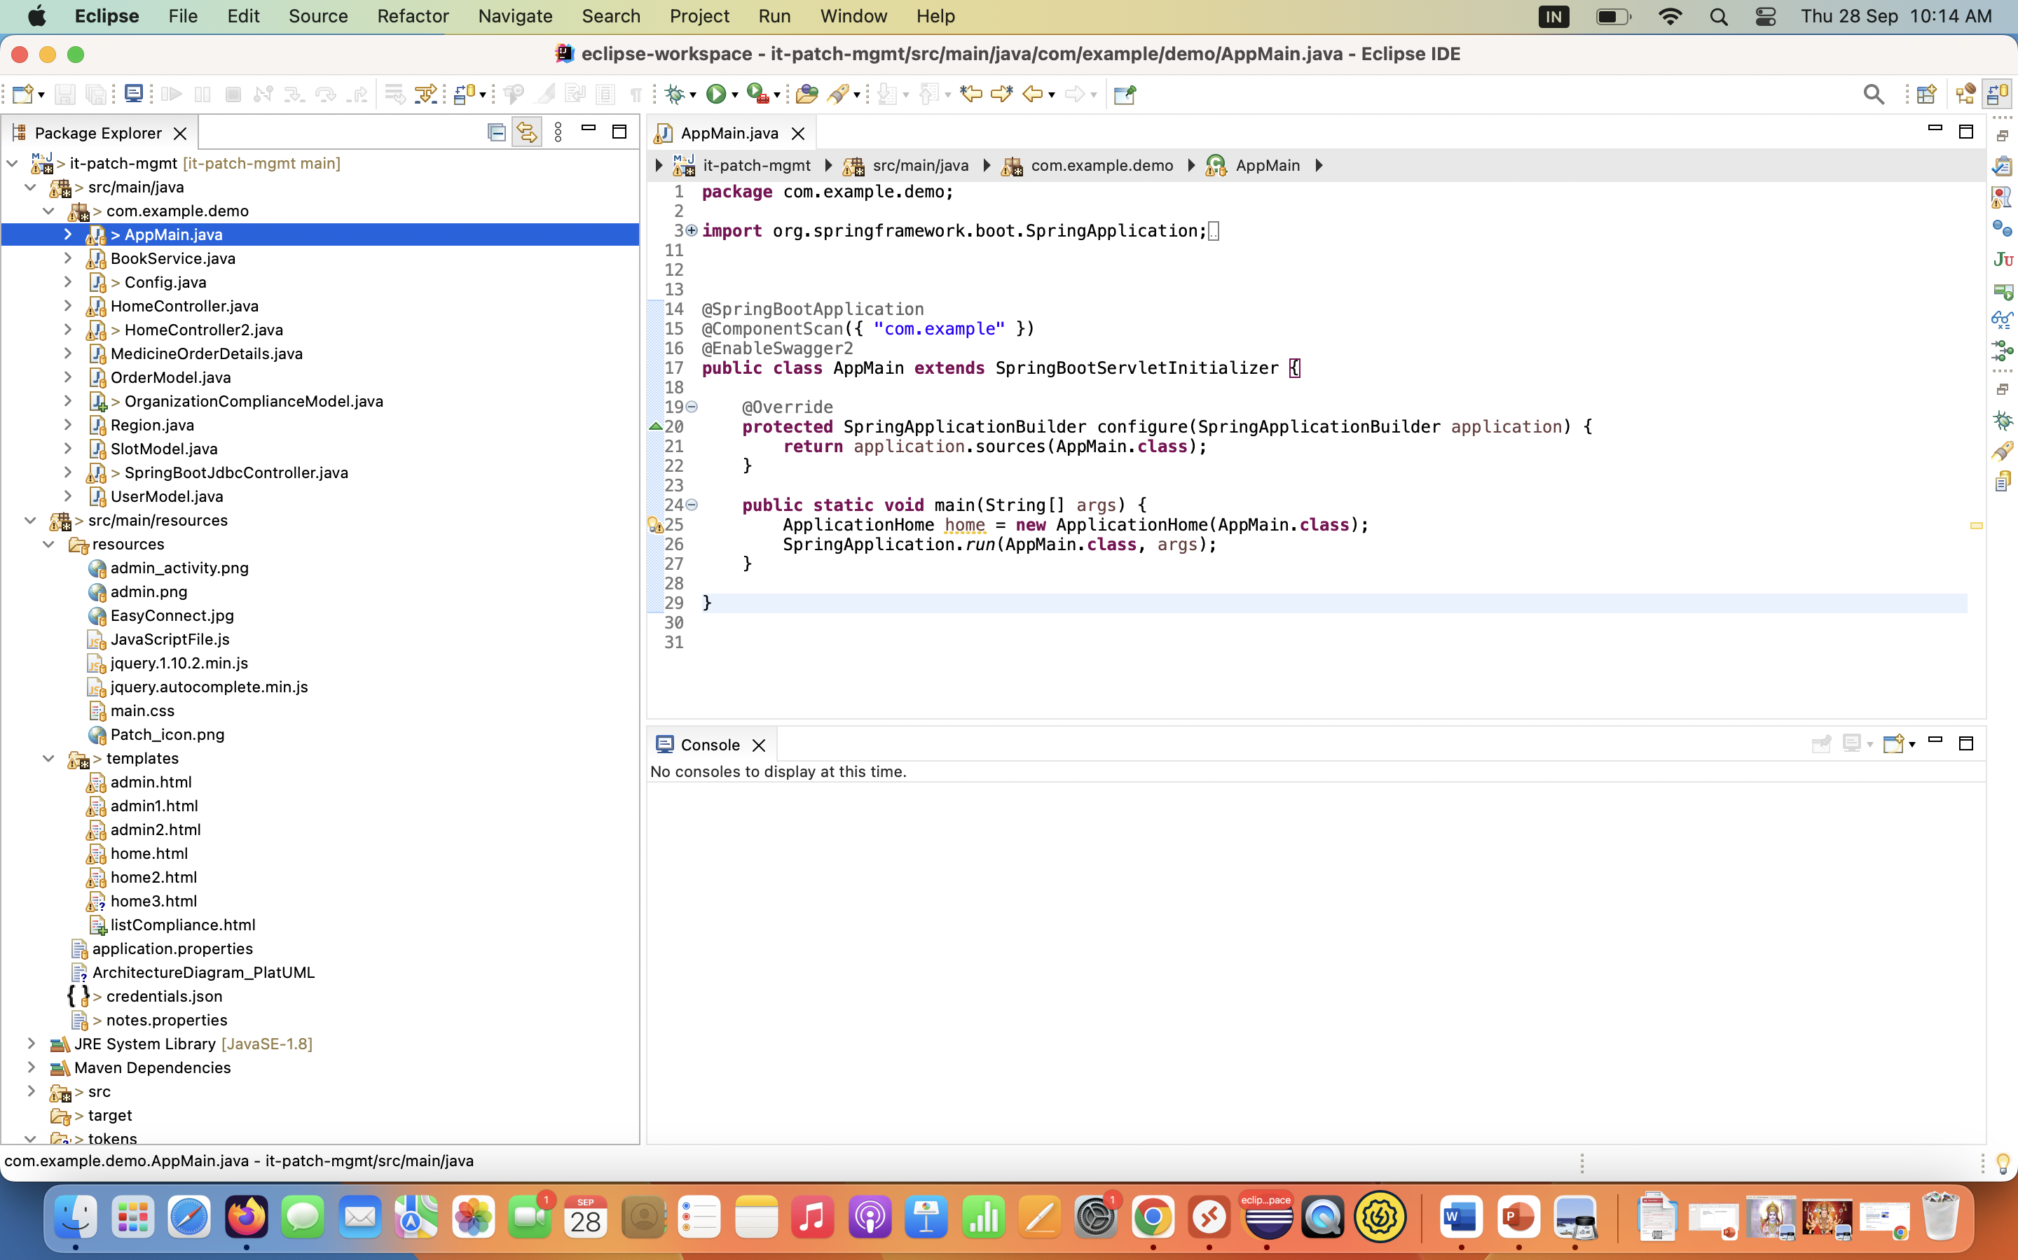

### Local Environment IDE

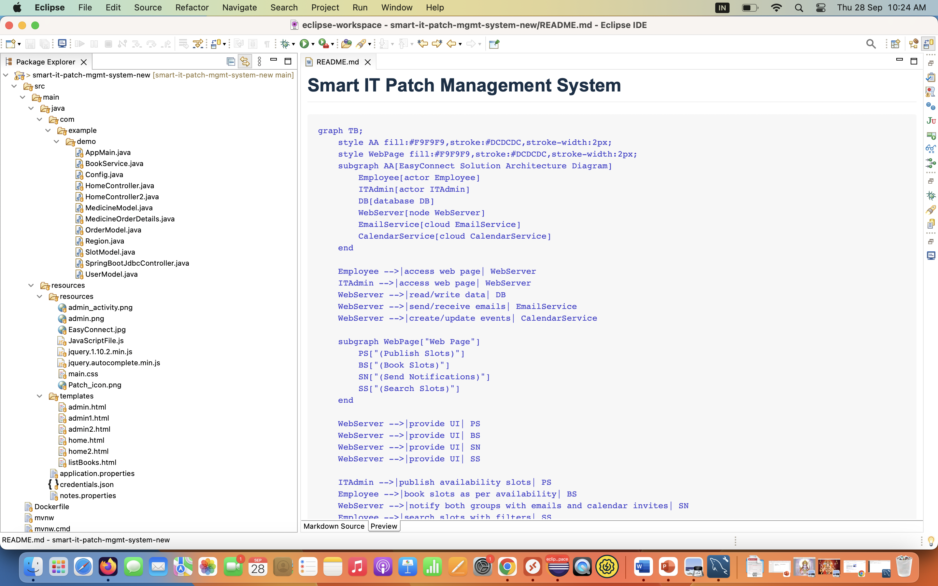

### [Diagram as Code (DAC)](https://icepanel.medium.com/top-7-diagrams-as-code-tools-for-software-architecture-1a9dd0df1815) in mermaid

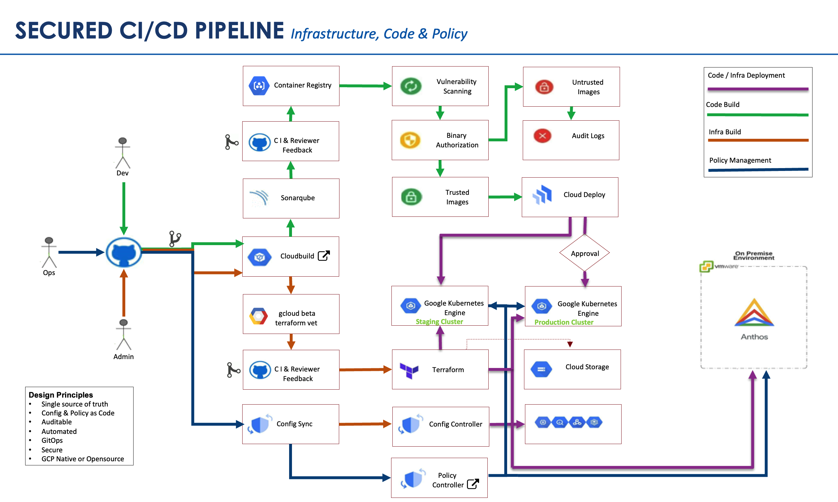

### DevSecOps Pipeline Design

## 

### LOAD BALANCING POLICIES

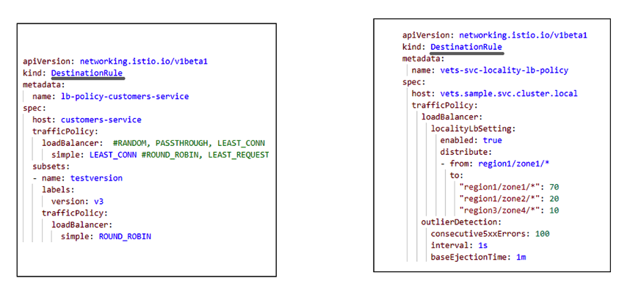

### policy-library

### <https://github.com/GoogleCloudPlatform/policy-library/>

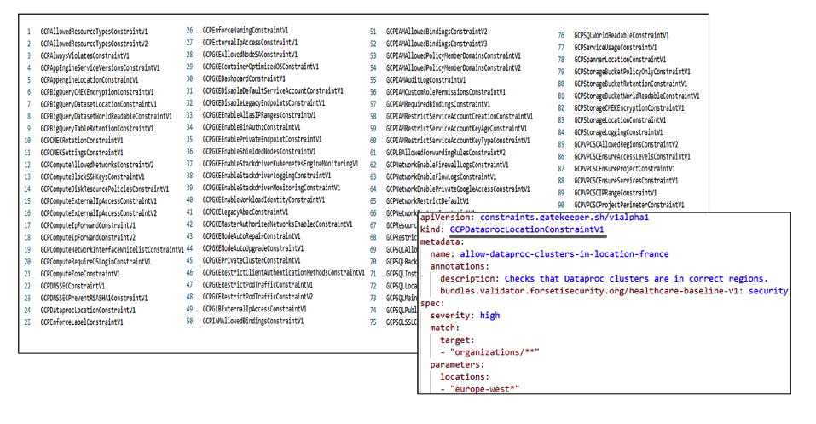

### Compliance Policies

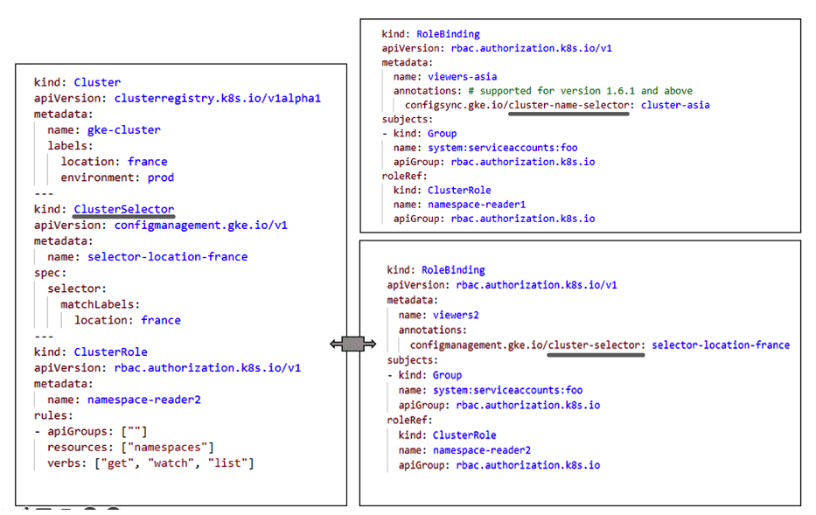

### App & infra build/deployment as a code

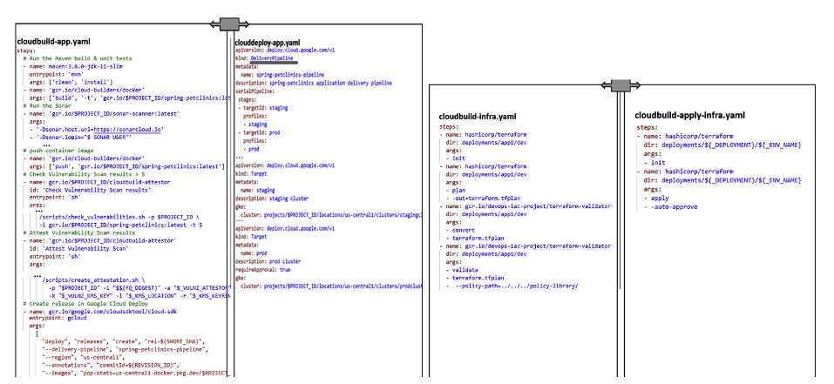

### Configuration management policies

